Machine Learning and Kalman Filtering for Precise Satellite Orbit Determination: Implications for Precise Point Positioning
Furkan KARLITEPE
Tokat Gaziosmanpasa University, Engineering and Architecture Faculty, Geomatic Engineering Department
furkan.karlitepe@gop.edu.tr

Introduction
Precise Point Positioning has emerged as a fundamental technique for achieving centimeter level accuracy using a single GNSS receiver by leveraging precise satellite orbit and clock products (Carlin et al., 2021; Öğütcü, 2019). Unlike differential approaches that eliminate errors through differencing with respect to a reference station, PPP relies on accurate models and correction information to achieve similar positioning accuracy (Chi et al., 2023). Broadcast ephemerides have been considered unsuitable for PPP due to their limited accuracy, though the emergence of new constellations such as Galileo and BeiDou-3 has prompted a reassessment of this constraint (Carlin et al., 2021; Alkan & Kalkan, 2011; Bahadur, 2023). Recent advancements in State Space Representation corrections and the operational deployment of augmentation services like the Centimeter Level Augmentation Service in the Quasi Zenith Satellite System have demonstrated that high accuracy positioning is achievable through the direct broadcasting of precise orbit and clock data via GNSS constellations (Naciri et al., 2023). The International GNSS Service has played a pivotal role by providing high quality GNSS data products since 1994, which include definitive satellite ephemerides and clock information necessary for correcting orbit and clock errors to reduce positioning error to the centimeter level (El‐Tokhey, 2019; Pandele et al., 2019). The International GNSS Service provides various levels of precise ephemerides and satellite clock corrections, with final products offering orbit accuracy of approximately 2.5 cm and clock precision around 75 ps, while ultra-rapid products deliver slightly degraded performance with near-real-time latency (Oliveira, 2017). To obtain this level of accuracy, PPP requires the rigorous modeling and correction of a comprehensive range of error sources, including satellite orbital and clock biases, satellite antenna phase center variations, receiver clock error, atmospheric delays, phase biases, solid earth tides, and ocean loading. Additional corrections such as relativistic effects, phase wind up, and pole tide must also be applied to ensure the integrity of the positioning solution (Aziz & Elsonbaty, 2021; Martín et al., 2015). Despite the availability of these precise products, PPP remains constrained by the latency of final orbit and clock corrections, which has driven the development of real time augmentation services and prediction models to support high precision applications (Tang et al., 2023; Yao et al., 2024; Öcalan & Soycan, 2011). Real-time PPP implementations necessitate the continuous availability of precise orbit and clock corrections, a requirement that has driven the development of augmentation services capable of delivering these products with minimal latency (Marques et al., 2014). In this context, the International GNSS Service initiated a pilot project for real-time activities in 2001 to improve RT-PPP accuracy, aiming to provide Real-Time Service products, primarily orbital and clock corrections, to mitigate satellite ephemeris and onboard clock errors (Qafisheh et al., 2022). The geodetic research community has investigated alternative orbit estimation strategies, including filter based smoothing and machine learning regression techniques, to enhance satellite coordinate reconstruction at observation epochs and improve positioning accuracy beyond the capabilities of conventional interpolation methods (Hankansurijat & Andrei, 2018; Hutton et al., 2016). This study addresses this gap by comparing Lagrange interpolation, an Extended Kalman Filter based smoothing approach, and machine learning models based on Random Forest regression and Support Vector Machines to evaluate their impact on PPP positioning accuracy. The evaluation is conducted using 1 Hz GNSS observations from a station with known coordinates, where satellite positions at observation epochs are derived from precise orbit products using ninth-degree Lagrange interpolation, an Extended Kalman Filter based smoothing approach, and machine learning regression models (Qafisheh et al., 2022; Tang et al., 2023). Machine learning algorithms have also been introduced to address PPP challenges, such as the estimation of Fractional Cycle Biases for integer ambiguity resolution, where Support Vector Machines have demonstrated superior performance compared to Random Forest models in enabling PPP-AR (Karlitepe & Erdoğan, 2025). Beyond ambiguity resolution, machine learning approaches have been investigated for predicting satellite orbit and clock corrections to mitigate the latency inherent in final products, with studies indicating that machine learning models can achieve centimeter level accuracy when modeling differences between ultra rapid and final orbit products. Specifically, sequential modeling algorithms such as Long Short-Term Memory networks have shown superiority in capturing the accumulation of prediction errors, achieving average improvements of 47% in 3D RMS within the 24-hour prediction interval and enhancing station coordinate accuracy by 16% when applied to kinematic PPP (Gou et al., 2023). Recent advancements in filter-based orbit determination have further demonstrated that real-time estimation strategies can outperform standard ultra rapid products in terms of convergence time and accuracy for kinematic PPP-AR applications (Lou et al., 2022). While these filter-based approaches have shown promise, recent studies indicate that purely machine learning methodologies can further augment traditional dynamic modeling, particularly for systems like BeiDou-3 where classical techniques exhibit notable performance disparities compared to GPS and Galileo (Xie et al., 2025). This observation underscores the necessity of system specific modeling strategies to ensure consistent multi-GNSS performance, as the distinct constellation architectures and signal characteristics of BeiDou-3 may not be fully captured by generic estimation frameworks (Mohanty & Gao, 2024). Recent studies have demonstrated that machine learning algorithms, particularly Long Short-Term Memory networks, can effectively model the non-linear relationships between ultra-rapid and final orbit products, achieving relative improvements of over 45% in orbit prediction accuracy and enhancing station coordinate precision by up to 16% in kinematic PPP applications (Gao et al., 2022; Gou et al., 2023). Similarly, Support Vector Machine-based solutions have been employed to reduce latency in PPP processing, achieving reductions of approximately 30% in the standard deviation and 20% in the range of clock corrections (Mohanty & Gao, 2024). Consequently, the geodetic community has investigated interpolation algorithms such as Lagrange polynomials to reconstruct satellite positions at the observation epoch from the sparse 15-minute or 5-minute intervals provided in standard precise products (Mohanty & Gao, 2024). While polynomial interpolation remains the standard approach due to its computational efficiency, studies have increasingly explored filter-based smoothing and machine learning regression techniques to better capture the behavior of satellite orbit between product epochs.

Methodology

Estimation satellite orbit with Kalman Filter
Kalman filter based estimation constitutes the foundation of the majority of modern navigation algorithms, supporting tasks such as inertial navigation system alignment and calibration, real time GNSS positioning (Groves, 2008). The Kalman filter maintains recursive estimates of time varying system states, including position, velocity, and attitude. Importantly, individual measurement updates are not required to ensure full state observability; instead, observability is achieved progressively through the temporal evolution of the filter and the accumulation of information across time. The filter is initialized with an a priori state estimate and its associated error covariance matrix. At each update cycle, predicted states derived from inertial dynamics are corrected using available measurements through a weighted fusion governed by the Kalman gain. This gain reflects the relative confidence assigned to the predicted state and the incoming measurement, ensuring that observations with lower uncertainty exert greater influence on the updated estimate. Owing to its recursive formulation, the Kalman filter is particularly well suited for real time navigation applications, as only the current state estimate and covariance are required and no historical data storage is needed.

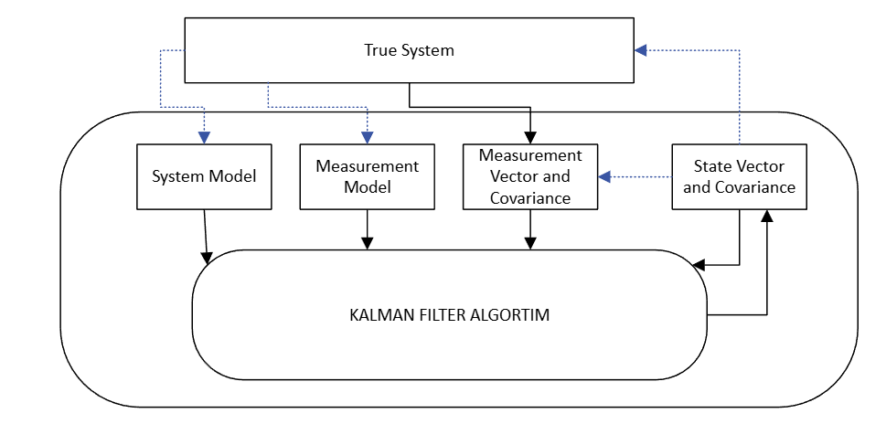
Figure 1: Elements of the Kalman filter (Groves, 2008).
Figure 1 illustrates the conceptual relationship between the true system and the Kalman filtering process, highlighting the five fundamental elements of the filter: the state vector and its error covariance, the system (process) model, the measurement vector and its covariance, the measurement model, and the Kalman filter algorithm itself.
The state vector represents the quantities to be estimated, which in navigation problems typically include position, velocity, and attitude related states. In the context of ArduPilot EKF.Yaw, this vector primarily contains yaw angle, angular rate related states, and gyroscope bias terms. The state vector does not only store the estimated values of these quantities but is accompanied by an error covariance matrix, which quantifies the uncertainty associated with each state and the degree of correlation between estimation errors.
The correlation information is of critical importance, as measurements are often insufficient to estimate all states independently. Instead, states that are not directly observable can be inferred indirectly through their correlation with other states. In EKF.Yaw, for example, gyroscope bias terms are not directly measured; however, they can be estimated through their growing correlation with yaw angle errors over time. Furthermore, during intervals without measurements, system dynamics and unmodeled effects cause these correlations and uncertainties to increase naturally.
The system model describes how both the states and their associated uncertainties evolve with time. States such as position or yaw angle are computed deterministically as the integral of other states, such as velocity or angular rate, based on known physical and kinematic relationships. While the state evolution itself is deterministic, the growth and coupling of uncertainties are tracked through the error covariance matrix. Thus, the system model is deterministic with respect to the state evolution but stochastic with respect to uncertainty propagation. In the absence of new measurements, the confidence in the state estimate must be deliberately reduced. Even with an accurate model, unknown dynamics, unmodeled disturbances, and random sensor effects may cause the true system to diverge from the predicted state. For instance, if acceleration is not measured, velocity may be assumed constant; nevertheless, the true velocity may vary, and its uncertainty must therefore increase over time. This behavior is captured by the process noise, which represents random variations in the true state values. In Kalman filtering, process noise is modeled through the process noise covariance matrix, whose statistical properties are typically defined during filter design based on system dynamics and sensor characteristics.
The measurement model defines the deterministic relationship between the true state vector and the measurement vector in the absence of measurement noise. That is, it expresses what the sensor should ideally measure given the true system state. For example, during INS calibration, the difference between the velocity measured by the INS and that provided by a reference system is directly proportional to the INS velocity error. Similar to the system model, the measurement model is deterministic, as it is based on known sensor geometry and measurement principles. The Kalman filter exploits this model to extract state error information from noisy measurements.

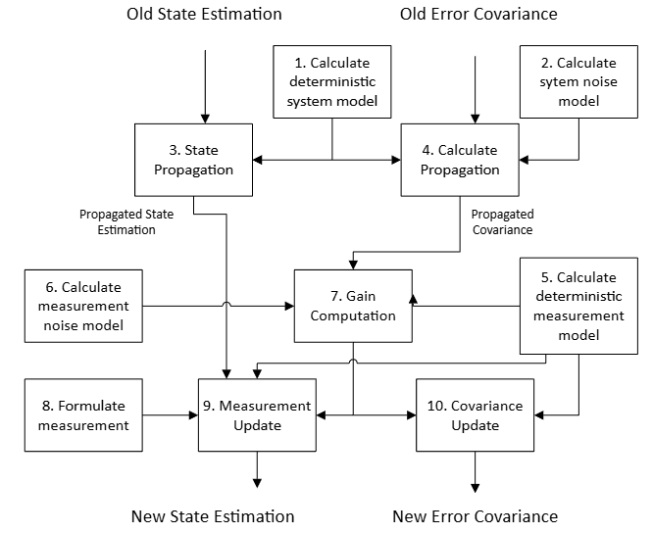
Figure 2: Flow of Kalman Filter
Figure 2 illustrates the step by step flow of the Kalman filter from an old state estimate to a new state estimate. In ArduPilot EKF.Yaw, this process is executed recursively and can be divided into state propagation and measurement update phases. Starting from the previous state estimate ${\hat{x}}_{k-1}^{+}$, the deterministic system model is first evaluated. In EKF.Yaw, this model describes the evolution of yaw angle based on gyroscope measurements and bias terms. The predicted (a priori) state is computed in Eq. (1).
$${\hat{x}}_{k}^{-}=f({\hat{x}}_{k-1}^{+}, u_{k-1})$$ | (1)
Where f(-​) represents the nonlinear system model and $u_{k-1}$ denotes known inputs such as gyroscope measurements.
In parallel with state propagation, the error covariance matrix is propagated to reflect increasing uncertainty and evolving correlations as seen in Eq (2).
$$P_{k}^{-}=F_{k}P_{k-1}^{+}F_{k}^{T}+Q_{k}$$ | (2)
Here $F_{k}$ is the Jacobian of the system model with respect to the state vector, evaluated at the predicted state, and $Q_{k}$ is the process noise covariance matrix. In EKF.Yaw, this step captures the growth of yaw uncertainty due to gyroscope noise and bias uncertainty, as well as increasing correlation between yaw and gyroscope bias states. When a new measurement becomes available, such as GNSS based yaw or magnetometer information, the deterministic measurement model is evaluated as seen in Eq. (3).
$${\hat{z}}_{k}=h({\hat{x}}_{k}^{-},)$$ | (3)
Where h(-) maps the predicted state to expected measurement. The reliability of this meas urement is characterized by the measurement noise covariance matrix $R_{k}$. The Kalman gain, which determines the relative weighting between the predicted state and the new measurement is then computed as seen in Eq. (4).
$$K_{k}=P_{k}^{-}H_{k}^{T}{(H_{k}P_{k}^{-}H_{k}^{T}+R_{k})}^{-1}$$ | (4)
Where $H_{k}$ is the Jacobian of the measurement model. This gain reflects how much the EKF.Yaw solution should trust the incoming yaw measurement relative to the inertial prediction. The measurement innovation is defined as seen in Eq. (5).
$$y_{k}=z_{k}-{\hat{z}}_{k}$$ | (5)
Accordingly, the state estimate is updated using the Kalman gain as shown in Eq. (6).
$${\hat{x}}_{k}^{+}={\hat{x}}_{k}^{-}-K_{k}y_{k}$$ | (6)
Although measurements may directly observe only the yaw angle, the existing correlation structure in the covariance matrix allows gyroscope bias states to be corrected indirectly. Finally, the updated error covariance matrix is computed as seen in Eq. (7).
$$P_{k}^{+}=(I-K_{k}H_{k})P_{k}^{-}$$ | (7)
which reflects the reduction in uncertainty resulting from the incorporation of the new measurement.

Results

Discussion

Conclusion

References
Alkan, R. M., & Kalkan, Y. (2011). Hassas Nokta Konumlama Tekniğinin Hidrografik Ölçmelerde Kullanılabilirliği. Jeodezi ve Jeoinformasyon Dergisi, 104.2, 100-106. https://izlik.org/JA77GC34CM
Aziz, K. M. A., & Elsonbaty, L. (2021). EFFECT OF USING DIFFERENT SATELLITE EPHEMERIDES ON GPS PPP AND POST PROCESSING TECHNIQUES. Geodesy and Cartography, 47(3), 104. https://doi.org/10.3846/gac.2021.13762
Bahadur, B. (2023). Küresel BeiDou Sistemi (BDS-3) için hassas nokta konumlama performansının değerlendirilmesi. Jeodezi ve Jeoinformasyon Dergisi, 10(1), 30-44. https://doi.org/10.9733/JGG.2023R0003.T
Carlin, L., Hauschild, A., & Montenbruck, O. (2021). Precise point positioning with GPS and Galileo broadcast ephemerides. GPS Solutions, 25(2). https://doi.org/10.1007/s10291-021-01111-4
Chi, C., Zhang, X., Liu, J., Sun, Y., Zhang, Z., & Zhan, X. (2023). GICI-LIB: A GNSS/INS/Camera Integrated Navigation Library. IEEE Robotics and Automation Letters, 8(12), 7970. https://doi.org/10.1109/lra.2023.3324825
El‐Tokhey, M. (2019). Assessment of Single and Precise Point Positioning Over Long Observational Periods. International Journal of Engineering Research And, 5. https://doi.org/10.17577/ijertv8is050112
Gao, W., Li, Z., Chen, Q., Jiang, W., & Feng, Y. (2022). Modelling and prediction of GNSS time series using GBDT, LSTM and SVM machine learning approaches. Journal of Geodesy, 96(10). https://doi.org/10.1007/s00190-022-01662-5
Gou, J., Rösch, C., Shehaj, E., Chen, K., Kiani Shahvandi, M., Soja, B., & Rothacher, M. (2023). Modeling the Differences between Ultra-Rapid and Final Orbit Products of GPS Satellites Using Machine-Learning Approaches. Remote Sensing, 15(23), 5585. https://doi.org/10.3390/rs15235585
Hankansurijat, C., & Andrei, C.-O. (2018). Atmospheric Water Estimation Using GNSS Precise Point Positioning Method. Engineering Journal, 22(6), 37. https://doi.org/10.4186/ej.2018.22.6.37
Hutton, J. J., Gopaul, N., Zhang, X., Wang, J., Menon, V., Rieck, D., Kipka, A., & Pastor, F. (2016). CENTIMETER-LEVEL, ROBUST GNSS-AIDED INERTIAL POST-PROCESSING FOR MOBILE MAPPING WITHOUT LOCAL REFERENCE STATIONS. The international Archives of the Photogrammetry, Remote Sensing and Spatial Information Sciences/International Archives of the Photogrammetry, Remote Sensing and Spatial Information Sciences, 819. https://doi.org/10.5194/isprsarchives-xli-b3-819-2016
Karlitepe, F., Erdogan, B. Machine learning algorithms for FCB (fractional cycle bias) estimation in PPP ambiguity resolution. Arab J Geosci 18, 139 (2025). https://doi.org/10.1007/s12517-025-12276-4
Lou, Y., Dai, X., Gong, X., Li, C., Qing, Y., Liu, Y., Peng, Y., & Gu, S. (2022). A review of real-time multi-GNSS precise orbit determination based on the filter method [Review of A review of real-time multi-GNSS precise orbit determination based on the filter method]. Satellite Navigation, 3(1). Springer Nature. https://doi.org/10.1186/s43020-022-00075-1
Marques, H. A., Monico, J. F. G., Shimabukuro, M. H., Oyama, R. T., & Wentz, J. P. (2014). PPP EM TEMPO REAL: FUNDAMENTOS, IMPLEMENTAÇÃO COMPUTACIONAL E ANÁLISES DE RESULTADOS NO MODO ESTÁTICO E CINEMÁTICO. Revista Brasileira de Cartografia, 66(6). https://doi.org/10.14393/rbcv66n6-44717
Martín, Á., Julián, A. B. A., Dimas-Pages, A., & Cos-Gayón, F. (2015). Validation of performance of real-time kinematic PPP. A possible tool for deformation monitoring. Measurement, 69, 95. https://doi.org/10.1016/j.measurement.2015.03.026
Mohanty, A., & Gao, G. (2024). A survey of machine learning techniques for improving Global Navigation Satellite Systems. EURASIP Journal on Advances in Signal Processing, 2024(1). https://doi.org/10.1186/s13634-024-01167-7
Naciri, N., Yi, D., Bisnath, S., Blas, F. J. de, & Capua, R. (2023). Assessment of Galileo High Accuracy Service (HAS) test signals and preliminary positioning performance. GPS Solutions, 27(2). https://doi.org/10.1007/s10291-023-01410-y
Öğütcü, S. (2019). Performance assessment of IGS Combined/JPL individual rapid and ultra-rapid products: consideration of precise point positioning technique. International Journal of Engineering and Geosciences, 5(1), 1. https://doi.org/10.26833/ijeg.577385
Öcalan, T., & Soycan, M. (2011). GNSS Verisinin Gerçek Zamanlı İletimi İçin Uluslararası Standartlar ve Gelişmeler. Jeodezi ve Jeoinformasyon Dergisi, 104.2, 123-133. https://izlik.org/JA26NY28UC
Oliveira, P. S. de. (2017). Definition and implementation of a new service for precise GNSS positioning. HAL (Le Centre Pour La Communication Scientifique Directe). https://tel.archives-ouvertes.fr/tel-01695792
Pandele, A., Cherciu, C., Trușculescu, M., Drăgășanu, C., & Mihai, S.-Ş. (2019). COTS based GNSS Receiver with Precise Point Positioning for CubeSats. MATEC Web of Conferences, 304, 7009. https://doi.org/10.1051/matecconf/201930407009
Qafisheh, M. W. A., Martín, Á., Capilla, R. M., & Julián, A. B. A. (2022). SVR and ARIMA models as machine learning solutions for solving the latency problem in real-time clock corrections. GPS Solutions, 26(3). https://doi.org/10.1007/s10291-022-01270-y
Tang, L., Wang, J., Cui, B., Zhu, H., Ge, M., & Schuh, H. (2023). Multi-GNSS precise point positioning with predicted orbits and clocks. GPS Solutions, 27(4). https://doi.org/10.1007/s10291-023-01499-1
Xie, S., Li, J., & Cai, J. (2025). Improving High-Precision BDS-3 Satellite Orbit Prediction Using a Self-Attention-Enhanced Deep Learning Model. Sensors, 25(9), 2844. https://doi.org/10.3390/s25092844
Yao, W., Huang, H., Ma, X., Zhang, Q., Yao, Y., Lin, X., Qingzhi, Z., & Huang, Y. (2024). Multi-Global Navigation Satellite System (GNSS) real-time tropospheric delay retrieval based on state-space representation (SSR) products from different analysis centers. Annales Geophysicae, 42(2), 455. https://doi.org/10.5194/angeo-42-455-2024

